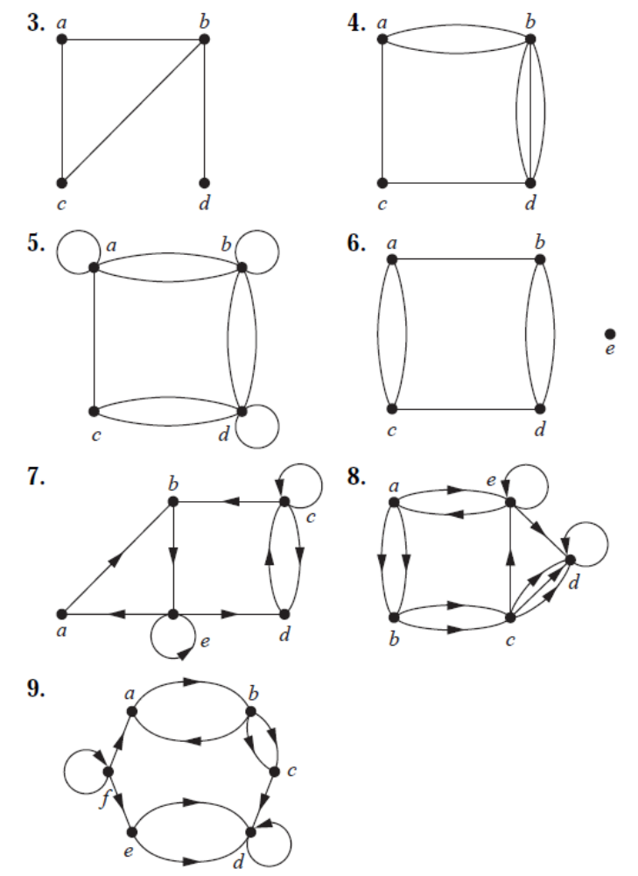
For Graphs 3–9, determine whether the graph shown has directed or undirected edges, whether it has multiple edges, and whether it has one or more loops. Use your answers to determine the type of graph in Table 1 this graph is.
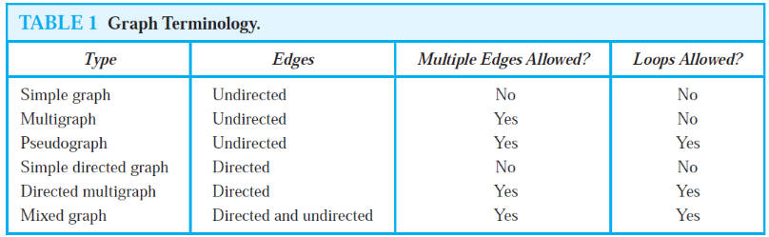
For each undirected graph in Graphs 3–9 that is not simple, find a set of edges to remove to make it simple.

The intersection graph of a collection of sets A1, A2, . . . , An is the graph that has a vertex for each of these sets and has an edge connecting the vertices representing two sets if these sets have a nonempty intersection. Construct the intersection graph of these collections of sets.
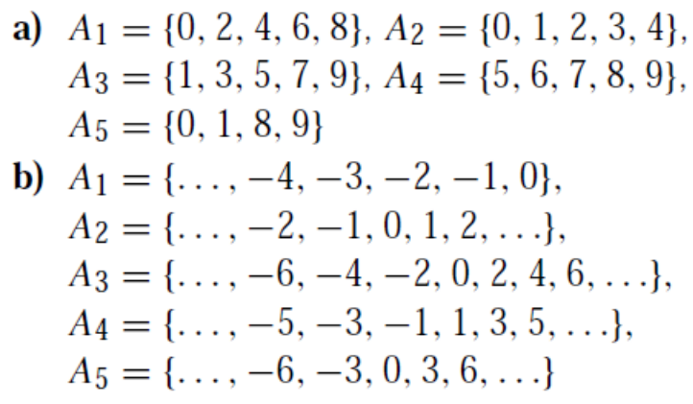
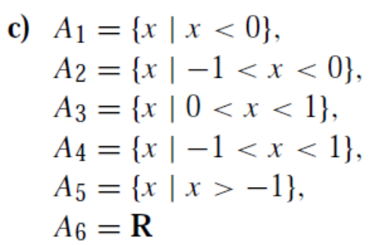

Construct a niche overlap graph for six species of birds, where the hermit thrush competes with the robin and with the blue jay, the robin also competes with the mockingbird, the mockingbird also competes with the blue jay, and the nuthatch competes with the hairy woodpecker.

Construct an influence graph for the board members of a company if the President can influence the Director of Research and Development, the Director of Marketing, and the Director of Operations; the Director of Research and Development can influence the Director of Operations; the Director of Marketing can influence the Director of Operations; and no one can influence, or be influenced by, the Chief Financial Officer.

In a round-robin tournament theTigers beat the Blue Jays, the Tigers beat the Cardinals, the Tigers beat the Orioles, the Blue Jays beat the Cardinals, the Blue Jays beat the Orioles, and the Cardinals beat the Orioles. Model this outcome with a directed graph.

For each course at a university, there may be one or more other courses that are its prerequisites. How can a graph be used to model these courses and which courses are prerequisites for which courses? Should edges be directed or undirected? Looking at the graph model, how can we find courses that do not have any prerequisites and how can we find courses that are not the prerequisite for any other courses?

Construct a precedence graph for the following program:
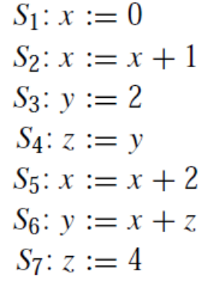
Which statements must be executed before S₆ is executed in the above program? (Use the precedence graph.)

In Graphs 1–3 find the number of vertices, the number of edges, and the degree of each vertex in the given undirected graph. Identify all isolated and pendant vertices.
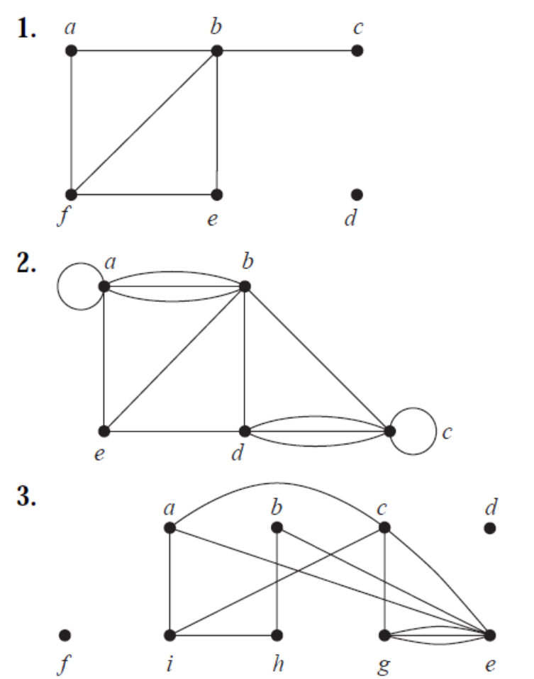
Find the sum of the degrees of the vertices of each graph in Graphs 1–3 and verify that it equals twice the number of edges in the graph.

Can a simple graph exist with 15 vertices each of degree five? Justify your answer with proper reasoning.

In Graphs 7–9 determine the number of vertices and edges and find the in-degree and out-degree of each vertex for the given directed multigraph.

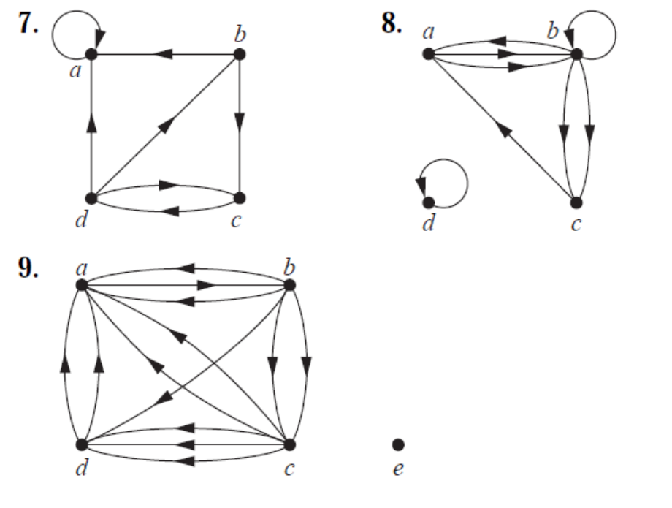
For each of the graphs in Graphs 7–9 determine the sum of the in-degrees of the vertices and the sum of the out-degrees of the vertices directly. Show that they are both equal to the number of edges in the graph.

The undirected graph that results from ignoring directions of edges is called the underlying undirected graph. (A graph with directed edges and its underlying undirected graph have the same number of edges.) Construct the underlying undirected graph for the following graph with directed edges.
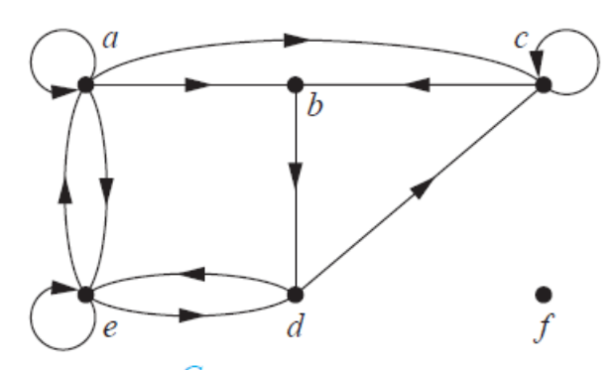

Show that in a simple graph with at least two vertices there must be two vertices that have the same degree.

For which values of n are these graphs bipartite?
a) K_{n} b) C_{n} c) W_{n} d) Q_{n}

In Graphs 21–25 determine whether the graph is bipartite. You may find it useful to apply the given Theorem and answer the question by determining whether it is possible to assign either red or blue to each vertex so that no two adjacent vertices are assigned the same color.
Theorem: A simple graph is bipartite if and only if it is possible to assign one of two different colors to each vertex of the graph so that no two adjacent vertices are assigned the same color.

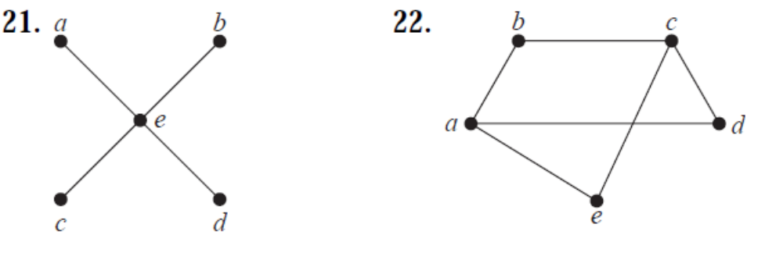
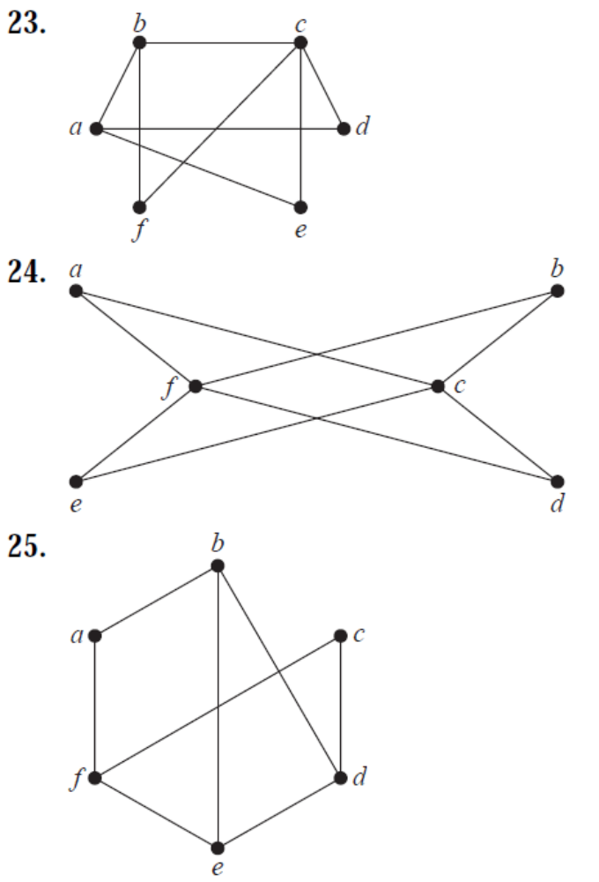

Suppose that there are five young women and six young men on an island. Each woman is willing to marry some of the men on the island and each man is willing to marry any woman who is willing to marry him. Suppose that Anna is willing to marry Jason, Larry, and Matt; Barbara is willing to marry Kevin and Larry; Carol is willing to marry Jason, Nick, and Oscar; Diane is willing to marry Jason, Larry, Nick, and Oscar; and Elizabeth is willing to marry Jason and Matt.
a) Model the possible marriages on the island using a bipartite graph.
b) Find a matching of the young women and the young men on the island such that each young woman is matched with a young man whom she is willing to marry.

For the graph G given below find
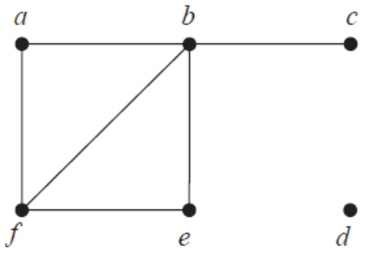
a) the subgraph induced by the vertices a, b, c, and f .
b) the new graph G1 obtained from G by contracting the edge connecting b and f .

How many vertices and how many edges do these graphs have?
a) K_{n} b) C_{n} c) W_{n} d) K_{m,n} e) Q_{n}

The degree sequence of a graph is the sequence of the degrees of the vertices of the graph in nonincreasing order.
Find the degree sequence of each of the following graphs.
a) K₄ b) C₄ c) W₄ d) K_{2,3} e) Q₃
What is the degree sequence of the bipartite graph K_{m,n} wheremand n are positive integers? Explain your answer.
What is the degree sequence of K_{n}, where n is a positive integer? Explain your answer.
How many edges does a graph have if its degree sequence is 4, 3, 3, 2, 2? Draw such a graph.
How many edges does a graph have if its degree sequence is 5, 2, 2, 2, 2, 1? Draw such a graph.

A simple graph is called regular if every vertex of this graph has the same degree. A regular graph is called n-regular if every vertex in this graph has degree n.
For which values of n are these graphs regular?
a) K_{n} b) C_{n} c) W_{n} d) Q_{n}
For which values of m and n is K_{m,n} regular?
How many vertices does a regular graph of degree four with 10 edges have?

Draw the mesh network for interconnecting twenty five parallel processors.
In a variant of a mesh network for interconnecting n=m² processors, processor P(i, j) is connected to the four processors P((i ±1) mod m, j ) and P(i, (j ±1) mod m ) so that connections wrap around the edges of the mesh. Draw this variant of the mesh network for 16 processors.

In Graphs 1–4 use an adjacency list to represent the given graphs.
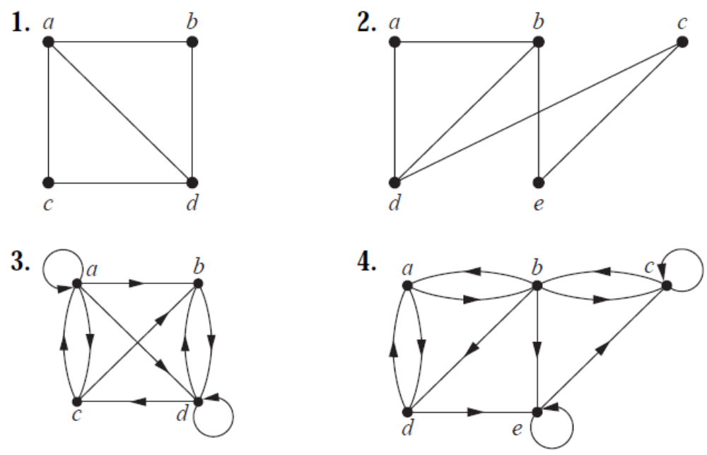
Now, represent the Graphs 1–4 with an adjacency matrix.

Use an incidence matrix to represent the Graphs 1 & 2.

In Graphs 34–44 determine whether the given pair of graphs is isomorphic. Exhibit an isomorphism or provide a rigorous argument that none exists.
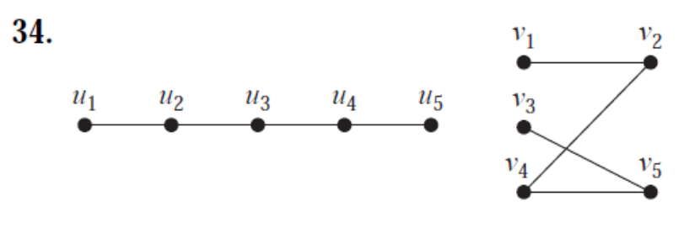

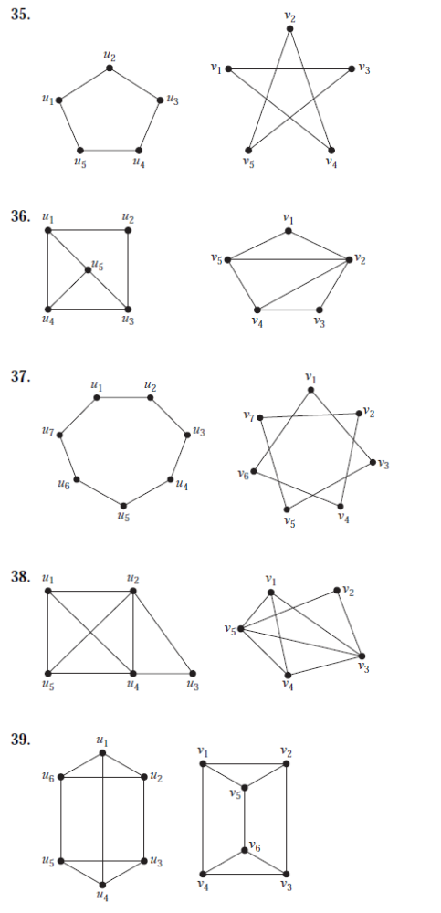

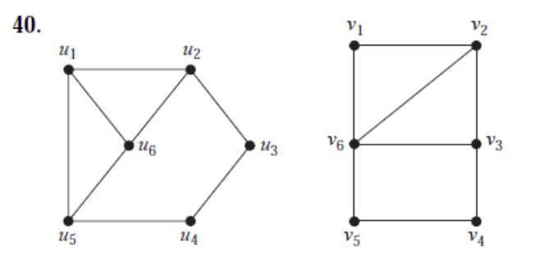
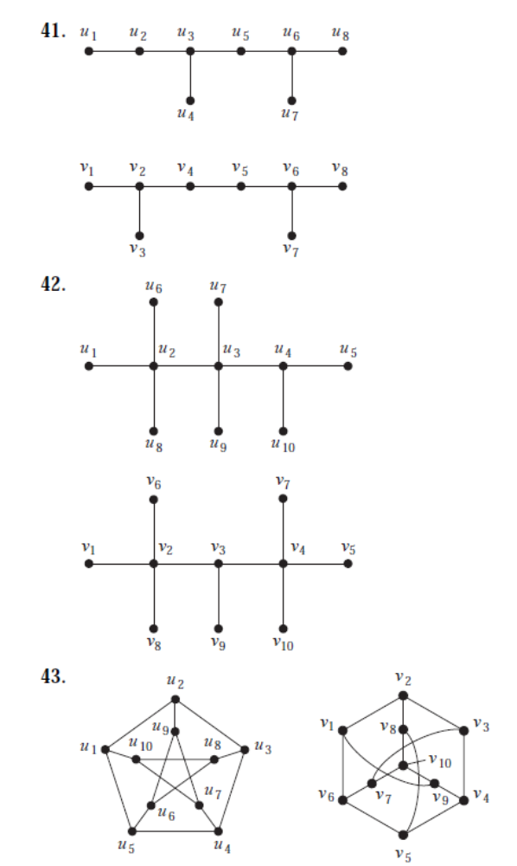
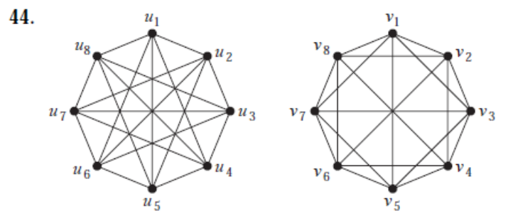

Show that isomorphism of simple graphs is an equivalence relation.

